**Submitted To: Engr. Ammad Khalil**

**Submitted By: Shah Raza (44)**

**Ashiq Ullah (77)**

**Section: B**

**Date: 20/10/2018**

Computer Fundamentals

Lab rePort #1

DEPARTMENT OF COMPUTER SYSTEM ENGINEERING, UET, PESHAWAR.

2018

Table of Contents

**INTRODUCTION TO COMPUTER HARDWARE** 2

**1.1 COMPUTER** 2

**1.2 HISTORY OF COMPUTERS** 2

**2.1 COMPONENTS OF A COMPUTER SYSTEM** 3

**2.2 HARDWARE** 3

**2.2.1 Input/output Devices:** 4

**2.2.2 Memory** 4

**2.2.3 Processor** 5

**2.2.4 Storage Devices** 6

**3.1** **INSIDE THE CPU** 8

**3.2 Power Supply** 8

**3.3 Data Cable** 8

**3.4 Network Card** 8

**3.5 Graphics Card** 9

**3.6 Motherboard** 9

**3.7 Sink** 10

# **INTRODUCTION TO COMPUTER HARDWARE**

**1.1 COMPUTER:**

* A computer is an electronic device which receives input data and process it into information.
* A computer is an electronic device which can solve different problems, process data and store it for later use.

**1.2 HISTORY OF COMPUTERS:**

The modern computer had its beginning in the 19th century when English Mathematician Professor Charles Babbage designed the Analytical Engine whose design was the basic framework for the computers of today.

Computers can be classified into five generations. Each generation lasted a certain period of time and gave either new computer or improvement to the existing computers. They are as follows:

1. **FIRST GENERATION (1940-1956):**

The 1st generation computers operated on vacuum tubes and magnetic drums. They were expensive to operate and consumed a great amount of electricity. In addition, they generated a lot of heat which caused damage to the computers.

These computers relied on binary language thus making it difficult to use. E.g. ENIAC and UNIVAC

1. **SECOND GENERATION (1956-1963):**

These computers operated on transistors instead of vacuum tubes. The transistors were superior to vacuum tubes as computers became cheaper, smaller and reliable. These computers moved from binary to symbolic language that allowed instructions to be given in words.

1. **THIRD GENERATION (1964-1971):**

In 3rd generation computers transistors were decreased in size and placed on silicon chips called semiconductors. Thus, resulting in the development of integrated circuits (ICs). The speed and efficiency were drastically increased. These were the first computers to become accessible to mass public because they were much cheaper and smaller in size. E.g. ICL 2900 and IBM 360.

1. **FOURTH GENERATION (1971-Present):**

As thousands of integrated circuits were built into single chip, microprocessor introduced 4th generation computers. These computers had located all their components from the CPU to memory to input/output controls on a single chip. As these computers became powerful, they could be linked together to form networks which resulted in the development of Internet.

1. **FIFTH GENERATION (Present):**

Based on the new Artificial Intelligence, 5th generation computers are still in development. The use of parallel processing and superconductors is making artificial intelligence a reality.

**2.1 COMPONENTS OF A COMPUTER SYSTEM:**

* Hardware
* Software
* Data
* User

**2.2 HARDWARE:**

The hardware refers to the physical parts that make up a computer or electronic system and everything that is involved in computer processing. Hardware is essential component of a computer because of which a computer exists physically.

Computer hardware is classified into four parts:

* Input/Output Devices
* Memory
* Processor
* Storage Devices

### **2.2.1 Input/output Devices:**

* Input devices are those devices which collect the data form user and then give this data to processer for processing.

**EXAMPLES:**

* Touch Screen
* Keyboard
* Microphone
* Light Pen
* Mouse
* Output devices are those devices which convert the result of data into a form that can be used and understood.

**EXAMPLES:**

* Computer Display
* Printer
* Projectors
* Plotter
* Speakers

**2.2.2 Memory:**

The main memory is the set of integrated circuits that temporarily store program instructions and data that can be retrieved. The main memory can be classified further into RAM and ROM.

* RAM (Random Access Memory) is the space in which data that is actively under review. Higher the RAM faster data can be viewed.
* ROM (Read Only Memory) stores data that does not commonly change, like startup instructions and data used when computer is first turned on.

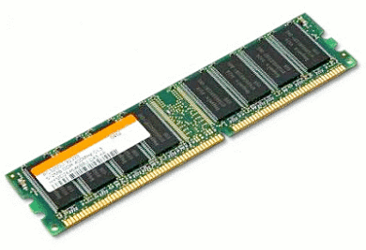

RAM

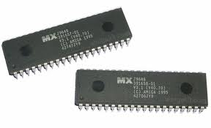

ROM

**2.2.3 Processor:**

Processor contain electronic circuits that cause the processing of data to occur. Processor is also called as the brain of computer. Part of the computer system where the computing is done. This is where the computer programs are executed.

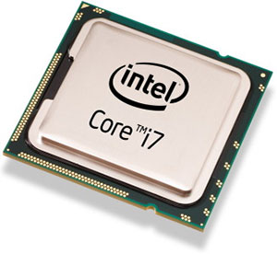

**The processor consists of ALU, CU and Register**

* ALU (Arithmetic Logic Unit) contains the electronic circuits necessary to perform arithmetic and logical operations.
* CU (Control Unit) is the component in any computer system that works in coordination with the CPU to instruct, maintain and control the flow of data.
* Register is a very fast computer memory. A register may hold an [instruction](https://whatis.techtarget.com/definition/instruction), a storage address, or any kind of data (such as a bit sequence or individual characters).

**TYPES OF PROCESSOR:**

|  |  |  |
| --- | --- | --- |
| **PROCESSOR** | **CORE(S)** | **SPEED(Hz)** |
| Intel Pentium | 1 | 50 MHz-66 MHz |
| Intel Pentium II | 1 | 66 MHz-100 MHz |
| Intel Pentium III | 1 | 100M -133 MHz |
| Pentium 4 | 1 | 400MHz-1066MHz |
| Dual Core | 2 | 533MHz-1066MHz |
| Intel Core | 1,2 | 533MHz-667MHz |
| Intel Core 2 | 1,2 | 533MHz-1600MHz |
| Intel Core i3 | 2 | 1066MHz-1600MHz |
| Intel Core i5 | 4 | 2.5-5 GT/s |
| Intel Core i7 | 4 | 4.8-6.4 GT/s |

**2.2.4 Storage Devices:** The device which storage the data that are not being used by the system. The data will be safe after the computer is turned off. Commonly this device is known as Hard Disk.

**TYPES OF STORAGE DEVICES:**

* **Magnetic Storage Devices:**  Magnetic storage uses different patterns of magnetization in a magnetizable material to store data and is a form of the non-volatile memory. Using one or more read/write heads the information is accessed. Magnetic storage stores data by magnetizing microscopic particles on the surface of the device, whether it’s a disk or it is a magnetic tape.

**EXAMPLES:**

1. Hard disk
2. Floppy disk

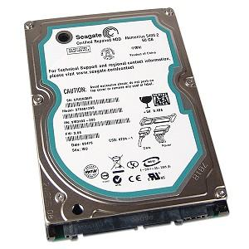

Hard disk

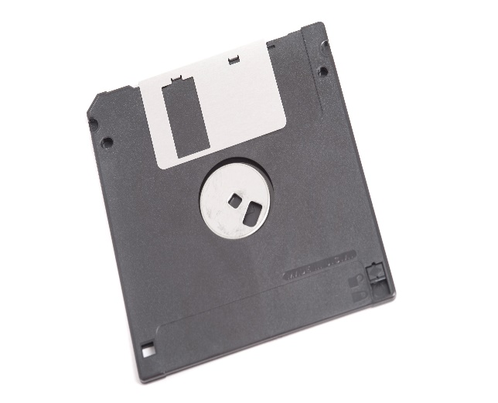

Floppy disk

* **Optical Storage Devices:**  Optical storage is any [storage](https://searchstorage.techtarget.com/definition/storage) method in which data is written and read with a [laser](https://whatis.techtarget.com/definition/laser) for [archival](https://searchstorage.techtarget.com/definition/archive) or [backup](https://searchdatabackup.techtarget.com/definition/backup) purposes. Optical media is more durable than tape and less vulnerable to environmental conditions. On the other hand, it tends to be slower than typical [hard drive](https://searchstorage.techtarget.com/definition/hard-disk-drive) speeds, and to offer lower storage capacities.

**EXAMPLES:**

1. CD
2. DVD

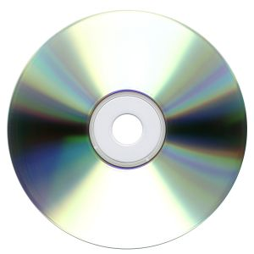

* 1. **INSIDE THE CPU:**

**3.2 Power Supply:** A power supply provides components with electric power. The term usually pertains to devices integrated within the component being powered. For example, computer power supplies convert AC current to DC current and are generally located at the rear of the computer case, along with at least one fan.

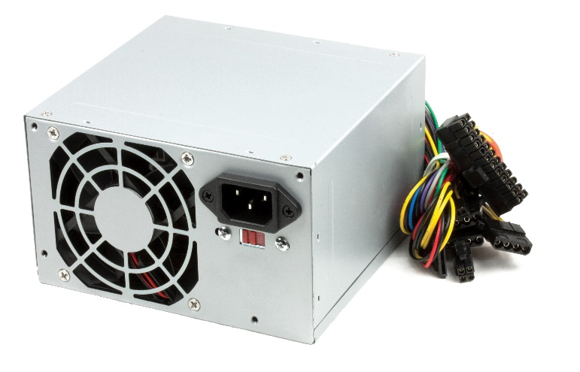

**3.3 Data Cable:** A data cable is a cable that provides communication between devices. For example, the data cable (i.e., DVI, HDMI, or VGA) that connects your monitor to your computer and allows your computer to display a picture on the monitor.

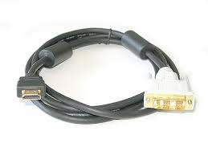

**3.4 Network Card:** A Network interface card (also known as a NIC, network card, or network interface controller) is an electronic device that connects a computer to a computer network, usually a LAN. It is considered a piece of computer hardware.

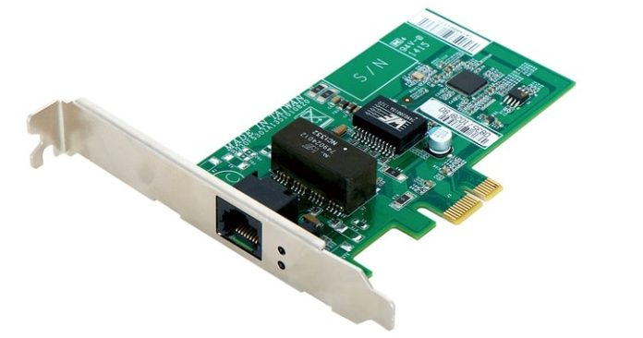

**3.5 Graphics Card:** A Graphics card is a type of display adapter or video card installed within most computing devices to display graphical data with high clarity, color, definition and overall appearance. A graphics card provides high-quality visual display by processing and executing graphical data using advanced graphical techniques, features and functions**.**

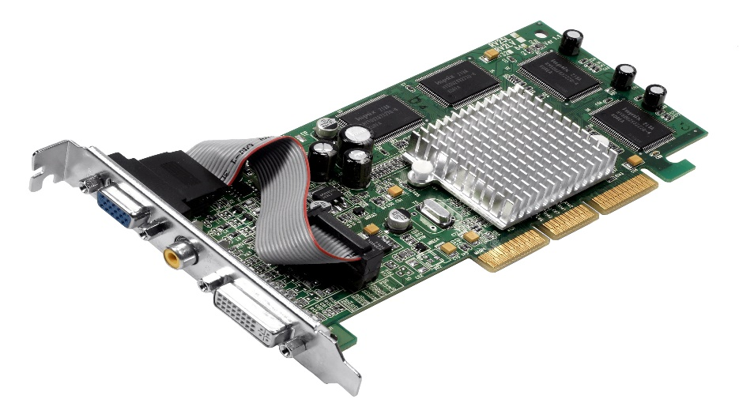

**3.6 Motherboard:** A motherboard is the main printed circuit board ([PCB](https://whatis.techtarget.com/definition/printed-circuit-board-PCB)) in a computer. The motherboard is a computer’s central communications backbone connectivity point, through which all components and external peripherals connect.

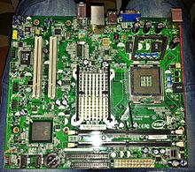

**3.7 Sink:** A heat sink is a thermal conductive metal device designed to absorb and disperse heat away from a high temperature object such as a computer processor.

